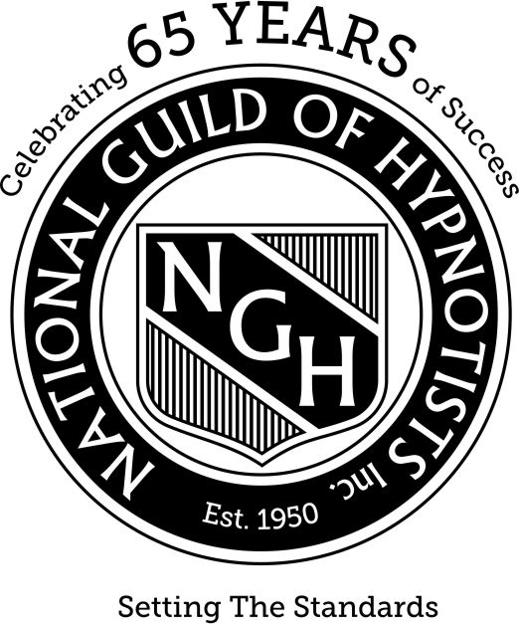

For Immediate Release

Is Hypnosis the Solution to Help You Solve Problems of Daily Life?

Deer Park, NY February 11, 2025 -- Professional consulting hypnotist, Bartlett T. Polster Jr, is taking part in a global education campaign to share the message that hypnosis is a simple, safe and highly effective way for people to address the problems of daily life. Routinely used in the health care industry as a valued tool, by athletes to improve focus and performance and by successful business professionals, celebrities and other high-profile individuals for relaxation and stress management, hypnosis also offers efficient applications for solving the types of problems people struggle with daily.

Presented by the National Guild of Hypnotists (NGH) ([www.ngh.net](http://www.ngh.net)), the nation’s oldest, largest and leading organization for professional consulting hypnotists, the campaign is sharing in-depth information about the role of hypnotists in helping people of all ages and with a range of problems. Deer Park, NY resident, Bartlett T. Polster Jr., a member of the National Guild of Hypnotists, is recognized for his services that help people break bad habits, establish healthy new routines and enhance their daily lives.

Among the many types of challenges that can be resolved or improved through hypnosis are: smoking cessation, overeating, emotional eating, cravings, exercise and activity levels, sports performance, stress reduction, sleep disorders, fear of speaking in public, test taking anxiety, increasing self-esteem, procrastination and other issues that hold people back from living their best life.

[Dr. Dwight Damon, President of the National Guild of Hypnotists](https://ngh.net/about/ngh-staff/) and one of the organization’s founders, explained, “The role of the consulting professional hypnotist may seem like a new profession in the minds of many consumers. In fact, the effective use of hypnosis is thousands of years old and is today accepted and proven throughout the medical community.” Dr. Damon is widely recognized as, “The Father of Consulting Hypnotism as a Separate and Distinct Profession.”

Bartlett Polster has been a member of the National Guild of Hypnotists since 2025. He is Certified in Advanced Reiki and Crystal Healing and uses Sound Healing Modalities as well.

Established in 1950, in Boston, Massachusetts, the National Guild of Hypnotists is the preeminent professional organization for consulting hypnotists. Over the years, the NGH has led the profession, receiving recognition in the United States Congressional Record for its accomplishments.

The organization has established a strict universal code of ethics for the profession and has developed and maintains a rigorous certification program based on a standardized curriculum. Extensive and ongoing training is required of National Guild of Hypnotists members receiving NGH certification.

Regularly, the NGH conducts educational seminars for its members and annually hosts an international convention and educational conference that includes a three-day intensive session with an additional two-week program of study also available. Each year, more than a thousand professional consulting hypnotists attend the NGH Convention.

In 1994, the National Guild of Hypnotists chartered the rapidly growing [National Federation of Hypnotists](https://ngh.net/legislation/nfh-union/), Local 104, a Union affiliated with the OPEIU, AFL-CIO, CLC. Currently the organization’s membership includes some 17,500 consulting hypnotists, located throughout 81 countries worldwide.

To learn more about Bart’s services in Deer Park, NY contact him directly at: [bpkjr@optonline.net](mailto:bpkjr@optonline.net). Find out more about the National Guild of Hypnotists at [www.ngh.net](http://www.ngh.net) or by calling 603-429-9438.

###

Contact information:

Bart Polster

[bpkjr@optonline.net](mailto:bpkjr@optonline.net)

[www.mindsetdevelopmentbppd.com](http://www.mindsetdevelopmentbppd.com)

631-492-0725

# **Here is how you can use the press release in your locale**

# Using the NGH Media Release Template in your Local Area:

* A **media release** **template,** designed for use by the NGH membership is included to make it easy for you to share the positive message of hypnosis with your local media and contacts.
* Also included is a copy of **Issue 5 of the NGH Convention Newsletter**, distributed in July 2015. We are including Issue 5 because it offers many handy tips and guidance on sharing your news with the media and with your readership, fans, and followers.

Instructions for Putting the Media Release Template to Work For You:

* Before you do anything else, you will want to save the template under a new file name with your documents or on your computer’s desktop.
* The release is titled: “Is Hypnosis the Solution to Help You Solve Problems of Daily Life?” You may use this as the title of your release or change the title. If you choose to retitle the release, you will want to apply these guidelines: keep the word **hypnotist** or **hypnosis** near the beginning of the title; choose a title that will engage the reader’s interest; and keep the title as close to 65 characters (including spaces) as possible.
* Any text that appears in red in the media release template should be replaced with your appropriate personal information, i.e., your name, your location, etc.
* When you have replaced all incidences of red text with the correct information, be sure you change the red text color to black. If you are unsure how to do this in Microsoft Word, follow this link to learn more: <https://support.office.com/en-us/article/Change-the-color-of-text-70d37d17-39d2-4e14-bb42-4ea2c23a5c3d>.
* Text that appears in blue in your media release template indicates a hyperlink. This text should **not** be changed.
* On page 2 of the media release template, you will find a paragraph created for sharing more of your professional bio information. Typically, you will want to limit this to one or two brief paragraphs, sharing the most meaningful facts about your professional career, training and practice.
* When you have made your edits and additions, save your document file. You may want to print it for mailing or hand delivering to your local media outlets or you may choose to include it in an email you send directly to your media contacts. Recognizing that attachments to emails often result in that email being routed directly to the recipient’s spam folder, it has become preferable to copy and paste your media release directly into the body of your email. Be sure to include a personal message first in the email, explaining to the recipient that you are sharing this news and hope they will consider including it in their publication/website/etc. Always add your contact information here and indicate that you are available for questions or interviews. Make it easy for the press to reach you to increase the likelihood that your media release is published.
* Following up on a media release with a personal phone call is always a good idea. You may not get through to your contact, but even a brief voicemail message can help attract the editor’s attention.